**KPI de ventes**

**Volume total des ventes (Total Sales)**

**create or replace view Total AS (**

**SELECT month(orderDate) AS mois, year(orderDate) AS ans, orderDate, productLine, productName, customerNumber, quantityOrdered, status, priceEach, comments, SUM(quantityOrdered*priceEach) AS CA_Total**

**FROM orders, orderdetails, products**

**WHERE (orders.orderNumber= orderdetails.orderNumber AND orderdetails.productCode=products.productCode)**

**Group by mois, ans, orderDate, productLine, productName, customerNumber, quantityOrdered,status, priceEach, comments**

**);**

**SELECT \***

**from Total;**

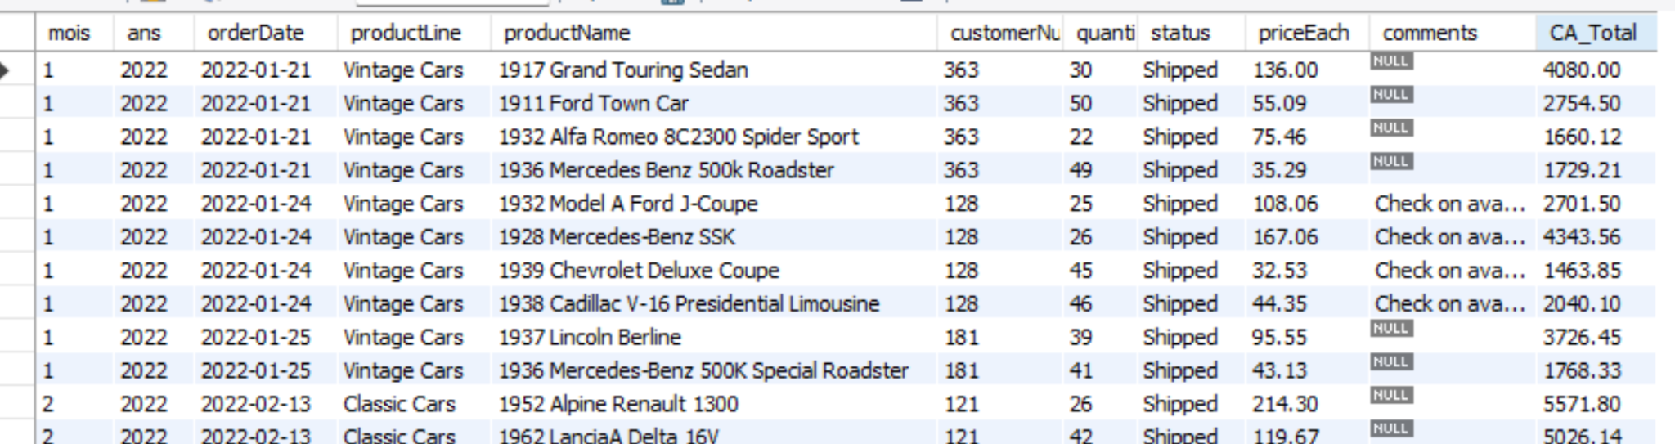

1. **Volume total des ventes (Total Sales)**
2. **Chiffre d’affaires total par catégorie (Total des ventes par catégorie)**
3. **Part de la catégorie dans le chiffre d’affaires total (Part des ventes par catégorie)**
4. **La comparaison et taux de variation par rapport au l’année précédente, MAX profitable, MIN profitable les produits dans les groupes**

**avec commentaires**

**create or replace view vendus_3 AS (**

**SELECT month(orderDate) AS mois, year(orderDate) AS ans, orderDate, productLine, productName, customerNumber, quantityOrdered, status, priceEach, SUM(quantityOrdered*priceEach) AS CA**

**FROM orders, orderdetails, products**

**WHERE (orders.orderNumber= orderdetails.orderNumber AND orderdetails.productCode=products.productCode) AND status = "Shipped"**

**Group by mois, ans, orderDate, productLine, productName, customerNumber, quantityOrdered, priceEach**

**);**

**SELECT \***

**from vendus_3 ;**



**Classement customer, TOP 20% customer qui donne 80% profit**

**WITH customer_total AS**

**(SELECT c.customerNumber, c.customerName, c.city, c.postalCode, c.country,**

**SUM(CASE WHEN YEAR(o.orderDate) = 2022 THEN od.quantityOrdered * od.priceEach ELSE 0 END) AS CA_2022,**

**SUM(CASE WHEN YEAR(o.orderDate) = 2023 THEN od.quantityOrdered * od.priceEach ELSE 0 END) AS CA_2023,**

**SUM(CASE WHEN YEAR(o.orderDate) = 2024 THEN od.quantityOrdered * od.priceEach ELSE 0 END) AS CA_2024**

**FROM customers AS c**

**JOIN orders AS o USING (customerNumber)**

**JOIN orderdetails AS od USING (orderNumber)**

**WHERE o.status = 'Shipped'**

**GROUP BY c.customerNumber, c.customerName, c.city, c.postalCode, c.country)**

**SELECT customerNumber, customerName, city, postalCode, country, CA_2022, CA_2023, CA_2024,**

**NTILE(5) OVER (ORDER BY CA_2022 DESC) AS group_customers_2022,**

**NTILE(5) OVER (ORDER BY CA_2023 DESC) AS group_customers_2023,**

**NTILE(5) OVER (ORDER BY CA_2024 DESC) AS group_customers_2024**

**FROM customer_total**

**ORDER BY customerNumber;**

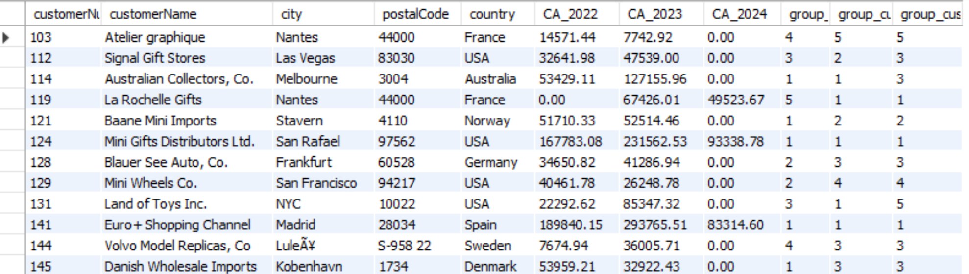

**TOP 5 produits par categorie, chaque année, par customer**

**WITH top_prod_productline as (**

**SELECT productline,**

**year(orderDate),**

**productname,**

**SUM(quantityordered *priceeach) AS CA**

**,RANK() OVER( partition by productline, year(orderDate) order by SUM(quantityordered * priceeach) DESC) as TOP**

**FROM products**

**INNER JOIN orderdetails USING(productcode)**

**INNER JOIN orders USING(orderNumber)**

**INNER JOIN customers USING(customerNumber)**

**WHERE status = "Shipped"**

**GROUP BY productline, year(orderDate), productname**

**ORDER BY TOP, CA desc)**

**SELECT \***

**FROM top_prod_productline**

**WHERE TOP <= 5 ;**

